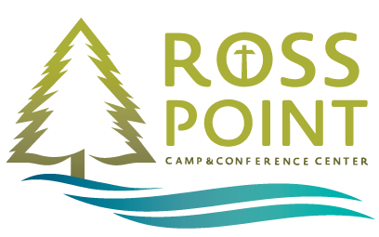Fact Sheet- Camp Journey 2017

Student: Bryan James

Faculty Mentor: Professor Jessica Boyer

Section: JRNM 453-01 Monday/Wednesday 1:00 PM- 3:00 PM

Name

Camp Journey

Location

Post Falls, Idaho

Directions:

From I-90 west, take exit 7 and stay in the middle lane. At Seltice Way, turn left (east) and stay in the right-hand lane. Turn right at the first light, which is Hwy 41 north and Ross Point Rd going south. After 3/4 mile, the road turns to the left and in that turn, the camp entrance is on the right. Follow the road for 1/4 mile to the main parking area.

From I-90 east, take exit 7 and stay in the right-hand lane. Turn right (south) at the light on Hwy 41. Go through the intersection at Seltice Way and continue on Ross Point Road. After 3/4 mile, the road turns to the left and in that turn, the camp entrance is on the right. Follow the road for 1/4 mile to the main parking area.

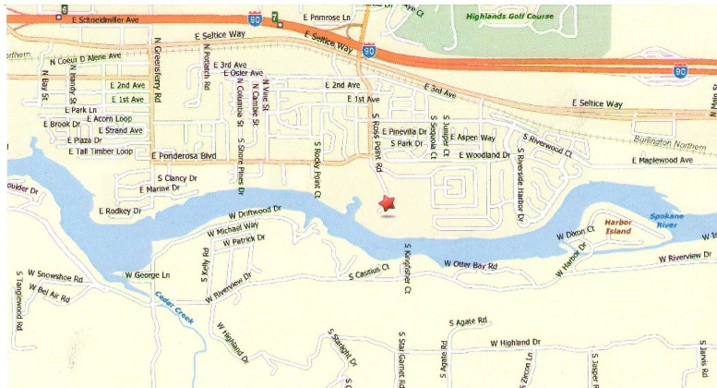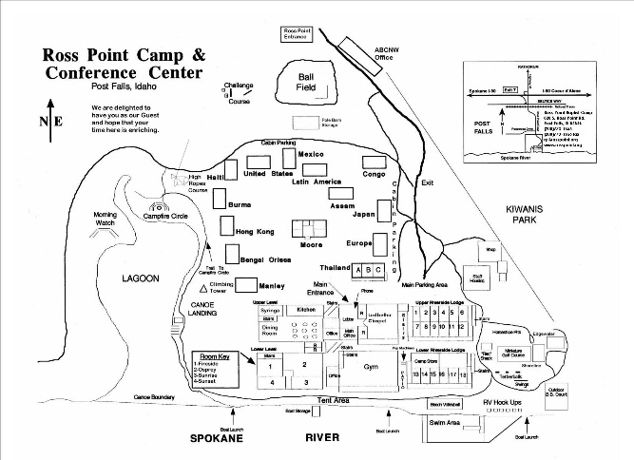

Description

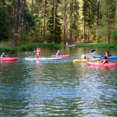Camp Journey is a camp providing a community of hope for children and their families touched by cancer.

Camp Journey was started in 1985 and has become a no-cost resident and day camp for children diagnosed with cancer, both children on and off therapy may attend. Camp Journey provides its campers with the opportunity to develop independence, confidence, acquire skills, make memories, and most importantly: They get to play and just be kids.

Where do Campers come from?

Campers most frequently come from Washington, Montana, and Idaho

# Camp Experience

* 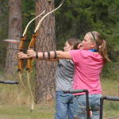Background: The camp originated in 1985 (get more information)
* Senior Leadership: Kari Allen, Camp Journey Director (Site mentions oncologists, who else can I put on to reassure overprotective parents?)
* Volunteer Staff: Approximately 75 volunteers, ages 18-70 (staff training specifics, what programs, ideally regulars) etc.
* Activities: Campers attending will enjoy swimming, the beach, Arts & Crafts, hiking, singing, campfires, naptime, and SPECIAL theme activities! (possible feedback, camper testimonies, return rates, etc.)

# Cost and Registration

Cost: The cost of Camp Journey is paid for via donation from caring individuals, organizations, and foundations that make this camp available without cost to campers and their families.

PayPal - The safer, easier way to pay online!Donation Opportunities:

If you’d like to donate just head on over to our [website](http://rosspoint.org/camp-journey) and click:

Application Process:

To register for Camp Journey, Download our [Camper Application 2017](http://rosspoint.org/wp-content/uploads/2013/12/Camp-Journey-CAMPER-Application-2017-md-jla4.pdf)

-OR-

Request an application from our Camp Director at 509-863-7379

-OR-

By email [kari@rosspoint.org](mailto:kari@rosspoint.org)